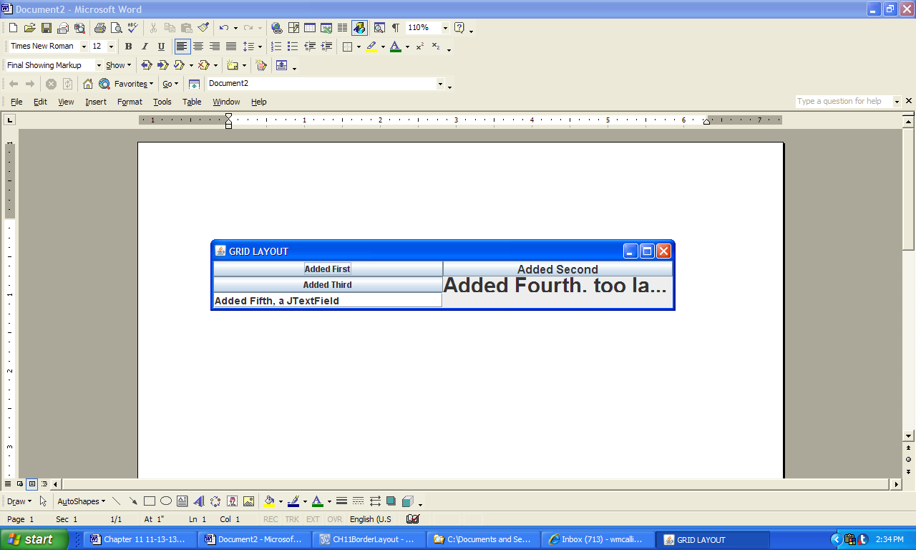

**Figure 11.38 A GUI built using the GridLayout manager.**